Homework # 12 – McNemar Change Test Tutorial on SPSS for WINDOWS.

Given Problem:
Before | After
Before | For My Opponent | For My Client
For My Client | 2 | 6
For My Opponent | 16 | 14

Null Hypothesis:
The numbers of voters going from my client to my client’s opponent was same as the number of voters going from my opponent’s to my client after the commercials was shown.

Alternative Hypothesis:
The numbers of voters going from my client to my client’s opponent was not equal as the number of voters going from my opponent’s to my client after the commercials was shown.

SPSS Data:

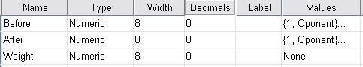

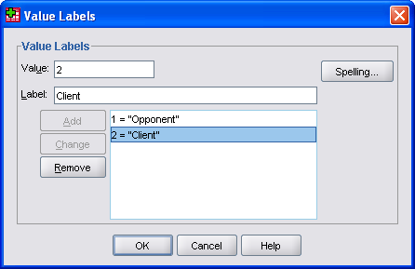

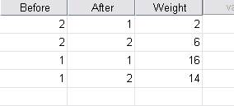

SPSS Command:

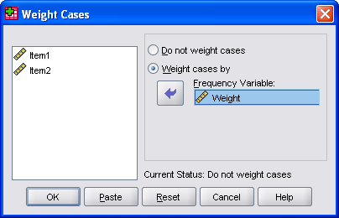



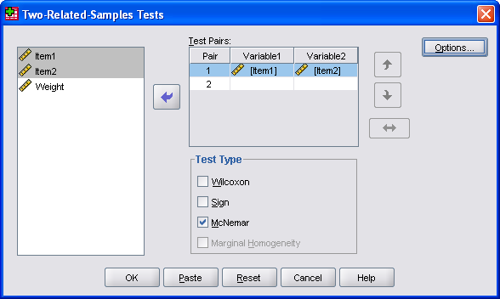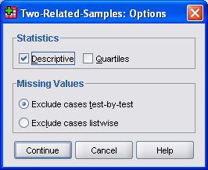

SPSS Output:

NPar Tests

Descriptive Statistics
 | N | Mean | Std. Deviation | Minimum | Maximum
Before | 38 | 1.21 | .413 | 1 | 2
After | 38 | 1.53 | .506 | 1 | 2

McNemar Test
Crosstabs
Before & After
Before | After
Before | Opponent |  | Client
Opponent | 16 |  | 14
Client | 2 |  | 6
Test Statistics^{b}
 |  | Before & After
N |  | 38
Exact Sig. (2-tailed) |  | .004ª
a. Binomial distribution used.
b. McNemar Test

Conclusion:
- The probability level of the test is p =.004

- If I were the research I would conclude that the test result is significant. I would then reject the null hypothesis.

- Conclusion: A study to determine if a series of television commercials in which a person running for public office attacks the character of his opponent has any effect on votes was carried out. A random sample of 38 voters was asked who they intend to vote for; the commercials containing the message are run for all the subjects. After viewing the commercials the 38 subjects were asked again who they intend to vote for. The results were as follows;

  - Two were for the client before and for the opponent after the commercials
  - Sixteen were for the opponent before and after
  - Six were for the client before and after
  - Fourteen were for the client after and for the opponent before.

As the expected frequencies are small enough, 14 and 2, A binomial test, instead of the McNemar change test was executed by the SPSS; and the result was found significant (p = .004). Thus, we reject the null hypothesis and conclude that there were more voters for my client who changed from my client’s opponent to him (n=14), after the commercials that was few (n = 2) before running the commercials.

